ARTHUR PARKE, SIM, B.P.15, PARAKOU, Benin. +229 97491307/94053987
UK +44 7753030497 arthur.parke@sim.org

PRAISE & PRAYER BULLETIN : May – September 2020

Yesterday the President of an African country aged 82 declared his candidacy for another term in office. Yesterday, though I am not yet that age, I visited our local cemetery to make sure there is room for me beside the three SIM missionaries buried there! At evening prayers, I shared with the seven ‘boys’ who were there my confidence in anticipating my eventual change of abode and my joy in being older and seeing how the experiences of life, good and not so good, all knit together to give me a view of the world and of eternity. It highlighted the uncertainty facing each one present: two failed their exams and will have to repeat their year in school, one goes into his last year in his lycée which had the worst results in the country in his subject (Industrial Electricity), another wants to proceed to university but his father has ten children and little hope of financing their education with his salary even when his mother chips in, another has dropped out of school to become a motor mechanic and has another two years to do in the church-run technical centre, and then there is John who is keeping pigs and rabbits alongside his mother, a pastor’s widow, who is managing on her small farm. Oddly enough our reading was from Genesis 3, which contributes to the feeling of uncertainty which dominated. Fortunately, several of the boys have understood the role that Christ offers to play in their lives.

“Yesterday” was in fact 10th September, and today it’s 3rd October. What sort of life do I lead here? Daniel, a student in Porto-Novo, the political capital of Benin, in the south, complained that I neglected him, and as he had lots of unanswered questions, he made the journey to spend ten days with me. After four days he shared that he had been waiting for an opportunity to have time with me but I always seemed to be occupied! Since starting this paragraph, there have been four interruptions. Before that I had had to make a trip into the town centre for Jean (=John) and two of his friends living in the same road to get a shared taxi to return to their Technical Lycée where they board. On Friday I had to go to the court house to amend Amédé’s birth certificate, but once he managed to get to the cashier to pay for the appropriate form, he was told it was out of print. Then at my bank, my card was refused by the ATM, allegedly out of date with 10/20 clearly marked on it! And so life goes on. I have my phone on ‘silent’ because of endless requests of my ‘old boys’ for help with school fees, unforeseen medical expenses or threats of being made homeless if overdue rents are not paid.
Just a glimpse of my lifestyle, which I don’t really want to exchange for solitary confinement in the comforts of my cosey Coleraine flat!

As schools are back, my priority is to see our Bible groups functioning again. I have several voluntary helpers but we cover the north of Benin, with schools almost 200 miles to the north-east and the same to the north-west which I have visited this year. Admittedly for the second trip I took a driver. I find these trips rejuvenate me, as I enjoy meeting with the young people, especially for Bible studies in small groups. As for our university groups, it is uncertain if/when lectures will begin.

PRAYER & PRAISE

- Thank the Lord for keeping me in Benin where I know no one affected by Covid19.
- Pray for mental and physical energy to make good use of my time!
- Pray for my ministry with the ‘boys’, three of whom have failed their exams. Pray for patience and wisdom in dealing with those who ought to be independent. Not easy.
- Thank the Lord for my helpers (‘staff’) and pray we may successfully contact Christian leaders in many schools to get groups going.
- SIM continues to have a ministry in Benin. Pray for missionaries arriving this month despite lots of tests and two weeks quarantine. When can I plan a trip to Ireland without problems?

SIM, 285a Woodstock Road, Belfast BT6 8PR Tel: 028 90451451 office@simireland.co.uk
SIM, Newmarket Road, Cambridge CB5 8RS Tel: 01223 788 288 www.sim.co.uk
GBEEB: Groupe Biblique des Elèves et Etudiants du Bénin(Bible groups schools and campus)

At the launching of a new group: Simon, my Far from Parakou with Simon and Osée
colleague left with a teacher and a friend. a local graduate and Obed school leader
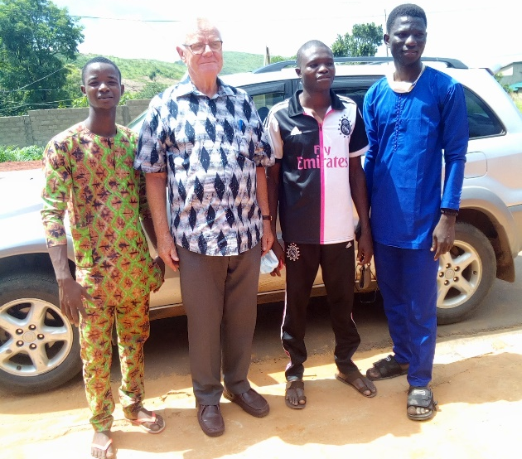
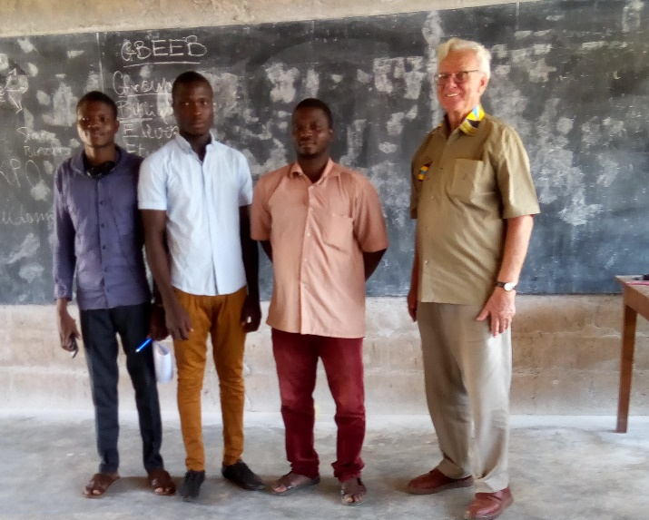

After 3 weeks holiday course in computing: With a small group. I always take a back seat:
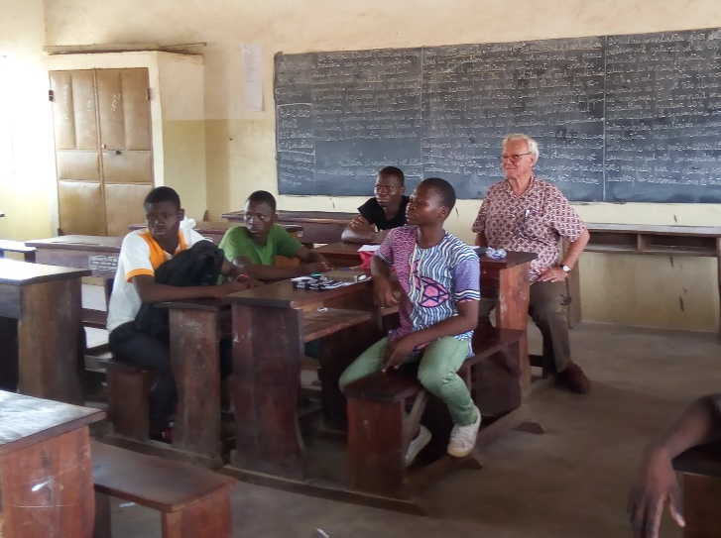
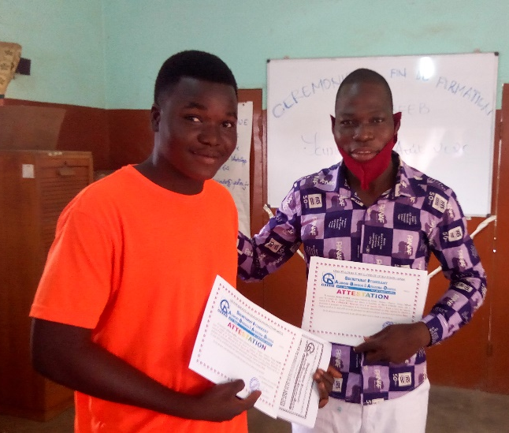
At our 3 day mini-camp to train leaders in our schools: (for once I am up front)
